Here, I chose the Salt River Watershed in Arizona. I created a watershed following the steps in the lab document. However, for an appropriate analysis, I used the surface watershed created by the Arizona Department of Water Resources (ADWR, 2021).

**Figure 1.** The Salt River watershed in Arizona showing Phoenix and Roosevelt Dam. USGS discharge data are available over Roosevelt Dam from 1987 onward.

|  |  |
| --- | --- |
|  |  |
| (a) | (b) |
|  | |
| (c) | |

**Figure 2.** Map screenshots of (a) GPM precipitation (P), (b) MOD16 evapotranspiration (ET), and (c) SMAP surface soil moisture (SSM). (a) and (b) are monthly totals in the original scales, i.e., mm/hr and 0.1mm/8days, respectively. (c) is in mm/3days scale.

|  |  |
| --- | --- |
|  |  |
| (a) | (b) |
|  | |
| (c) | |

**Figure 3.** Raster plots of (a) GPM P, (b) MOD16 ET, and (c) SMAP SSM with the same units as in Figure 2.

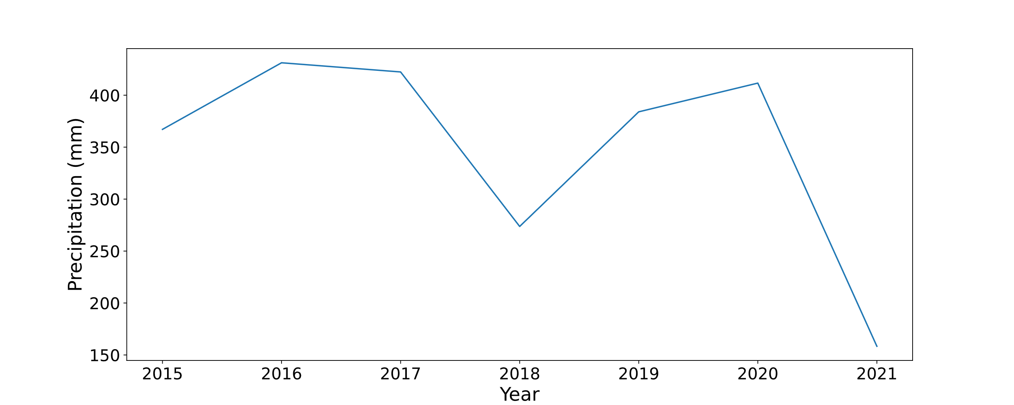

**Figure 4.** Total precipitation over the entire watershed from 2015-2021.

Figure 4 shows that the total precipitation has sharply declined in 2021.

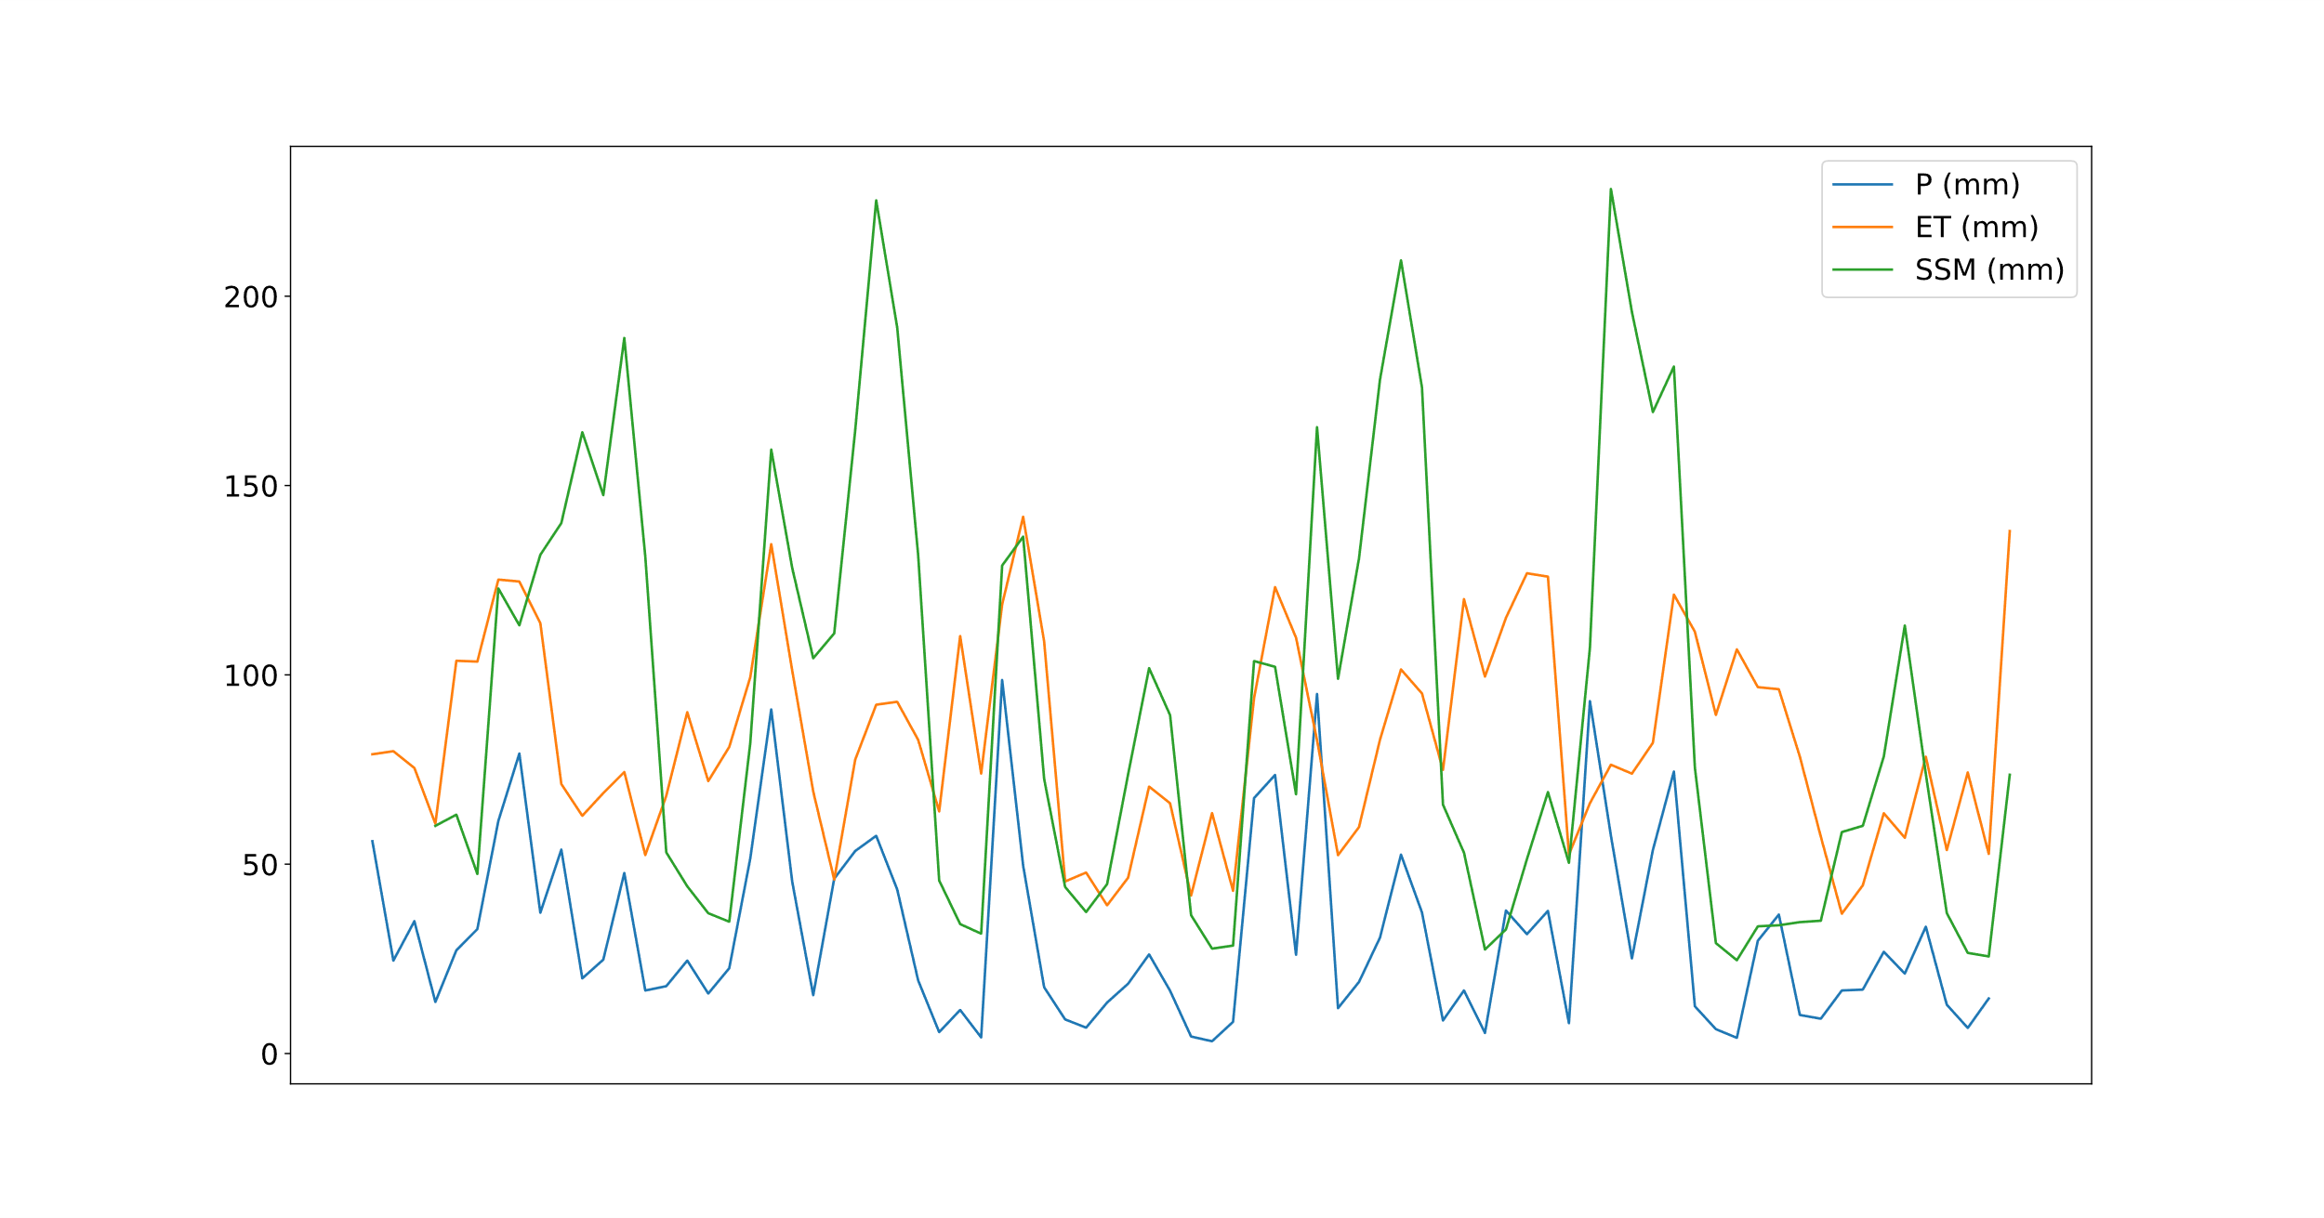

**Figure 5.** Time series of the monthly (a) total GPM P, (b) total MOD16 ET, and (c) mean SMAP SSM from January 2015 to July 2021.

The time series shows that the three water balance components, P, ET, and SSM, exhibit similar patterns. All of them are quite low because of semi-arid to arid conditions in the watershed. The sharp decrease in precipitation in 2021 is observable. Noticeably, ET is quite in 2021 compared to some of the previous years.

**References**

ADWR. (2021). *GIS Data and Maps*. https://new.azwater.gov/gis